Classification Models Comparison

Angela Li ()
Franco Doi (30270314)
Gautham Shekariah (30273439)
Joao Targino (30271085)

- Introduction
Customer acquisition is one of the hardest and costly parts of running a business, especially nowadays when online services such as pricing comparison tools, forums and discussion groups, empowered people to change more often and made the shopping momentum an easy and quick task.
Companies usually spend a large part of their marketing budget on different channels with the purpose of acquiring customers and, since it is not cheap, watching clients cancel their services (or stop shopping at your store) with a Return on Investment (ROI) lower than 1 is a challenging situation for any marketing professional.
With more companies adopting Data Science and Machine Learning on their decision-making process, models were developed to predict within certain accuracy if (or when) a customer is likely to leave your company and take their business to the competitors.
- Project Goals
In the past years, a large variety of models were developed and improved to serve as a guide for these types of situations. The type of model that this project intents to study are on the Classification Models drawer, which based on the past behavior of the customer base will produce a probabilistic result of current active clients to leave – or not.
The purpose is to produce a head-to-head comparison between advanced techniques such as LightGBM (Light Gradient Boosting Machine) and XGBoost (Extreme Gradient Boosting) with simpler and easy-to-adopt options such as Logistic Regression, and discuss in each case the difficulties, differences, overall data requirements and performance.
- Data
For this report, the dataset used in this analysis is public available from Kaggle and contemplate 7,043 observations of customers from an American telecommunications company, alongside with 50 aspects.
The dataset combines numerical aspects such as Lifetime Value, Monthly Charges, Tenure in Months, Age with categorical columns such as Payment Type, Contract Type (Monthly, Annual, Biannual), Service Type (Internet, Phone Service, etc.).
As expected in real-world data, data cleaning and wrangling steps were done to guarantee proper adoption for all models and produce a fair comparison. These steps will be further discussed in the appropriate section.

- Methodology
  - Data Cleaning
The chosen dataset was very comprehensive and most of the wrangling steps were done not to correct errors but to guarantee that the modelling was done correctly and the results were trustworthy.
Columns with unique values for each customer were removed from the ingested data because they would not serve as a good predictor. Customer ID, Latitude, Longitude, Zipcode and Population (from the city where the customer lives) are among these.
Moreover, columns with a unique value for all the observations were also removed, such as Country (United States), State (California), Quarter (Q3),
Lastly, predictors with collinearity with the result variable or within other columns were also removed from the dataset, such as Satisfaction Score (highly correlated with Churn), Churn Score (highly correlated with the response variable), Customer Status (Churned, Active or not) and Churn Reason (only available for churned customers).
No missing data or outliers were treated before or after the data cleaning process, which resulted in the same 7,043 observations, however with 35 predictors (14 numerical and 21 categorical) remaining.
  - Data Preprocessing
After the step described above, the preprocessing phase consisted in transformations within the predictors before the ingestion in the model.
Logistic Regression (LR) only accepts numerical values; all categorical columns were transformed into binary (“dummy”) variables with exclusion of the first option (to avoid overfit). The other models received the categorical columns as-is, only with the data type changed to “category” because they could handle it without issues.
Regarding the numerical columns, for all models the Standard Scaler technique was used to improve predicting results and take care of zeroes on some of the columns.
4.3 Modelling Parameters
Applying best practices to deal with classification models, it was used K-Fold Cross Validation method and parameter sweeping in models that required this approach (Random Forest).
The data, although comprehensive, was imbalanced (26% Churned, 74% Active), which led to a decision to use stratification for the Cross Validation.
4.4 Error Types and Model Evaluation
Classification problems may present two types of errors, and both should be closely monitored to guarantee the company’s efficiency and save costs.
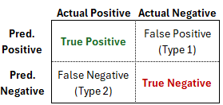
Fig 1. Confusion Matrix

For churn modelling, Type 1 and Type 2 errors can result in monetary losses. Type 1 Error would result in the company giving incentives to customers that did not intend to cancel their services. Type 2 Error would lead to failure in identifying customers with this intention, so no offer or other preventive action could be taken to retain this client.
In terms of results, each model was solely evaluated using the following metrics:
- Confusion Matrix: guarantees a visual and easy-to-interpret inspection of the results, with the absolute numbers of True Positives and False Negatives.
- F1 Score: this metric is a balanced view between Accuracy and Recall, which are the highest value for any classification/churn model.
- Recall: because the false negatives (customers that churned when the model predicted that they would not) are costly, Recall should be also monitored.
- ROC Curve: important visualization metric to monitor True Positive Rates and False Negative Rates.

- Results Analysis
  - Logistic Regression
Logistic regression presented a satisfactory result when predicting customers that would churn. Out of the 1,869 customers that churned, the model correctly identified (True Positive Rate) 1,251 (67%). On the other hand, out of the 5,174 customers that did not churn, the model correctly identified (True False Rate) 4,691 (91%).
The average F1 score across 10 folds was 69.4% while the Recall Score averaged at 69.9% and the ROC curve had a Mean AUC of 90.3%.
Moreover, the contract type (especially Two Year), number of referrals and monthly charges were the best predictors. These three can be classified as customer engagement metrics, which make them plausible as good predictors for cancellation.
Feature Importance
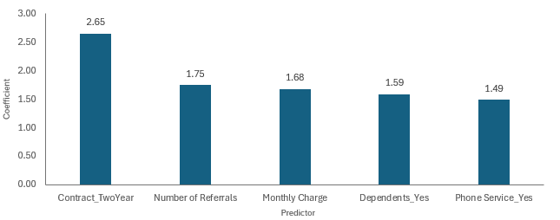
Fig 2. Feature Importance for Logistic Regression Model
ROC Curve
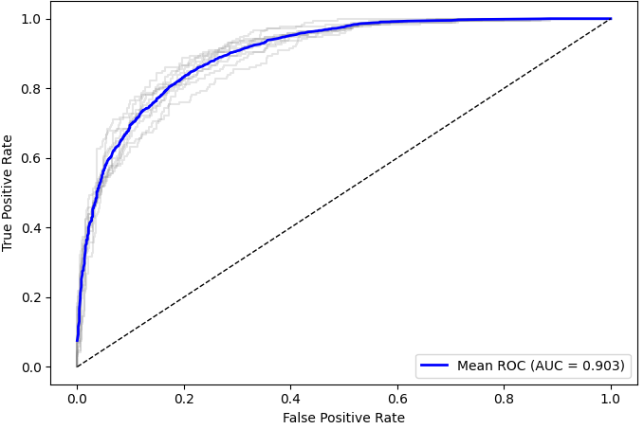
Fig 3. ROC Curve Logistic Regression Model
Lastly, from the ROC curve and the result of AUC, it is possible to see that the numbers were consistent throughout the folds, and the shape of curve is exactly what was expected.
  - Decision Tree
Decision Tree was the simplest and least effective of the models tested within this dataset and the overall result corroborated this assumption. This iteration was able to identify 59% of the customers that churned, while identifying 85% of the customers that remained active.
The issue with this model was the False Negative Rate – 11.3%. which led to an overall low F1 Score of 58.8% and a Recall of 59.4%, alongside with an average AUC of 72%

Feature Importance
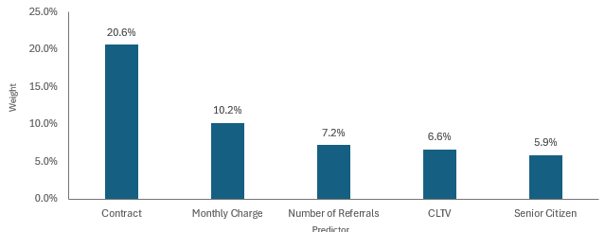
Fig 4. Feature Importance for Decision Tree Model
ROC Curve
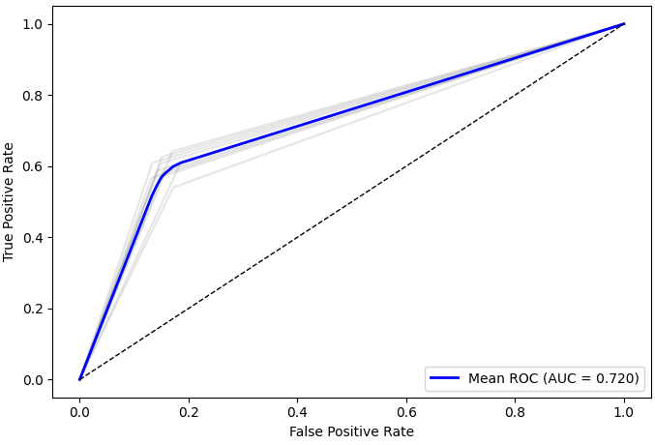
Fig 5. ROC Curve for Decision Tree Model
5.3 XG Boosting
Boosting models are great options for churn predictions and XGBoosting is a popular choice to solve this type of problem. In this case, to guarantee that the model had the best result possible (without overfitting), different values for parameters such as learning rate and max depth of each branch were tested.
learning_rate | 0.10
max_depth | 5
Table 1: Optimal Parameters for XG Boosting

The test with this model resulted in 65% of the churned customers correctly identified, while also identifying 91% of the customers that didn’t churn.
Overall, all the scores were robust and demonstrated a good prediction power within this dataset. XGBoosting reached 70.8% on F1 Score and 67.5% on Recall, alongside with 90.7% on AUC, slightly above Logistic Regression.
Feature Importance
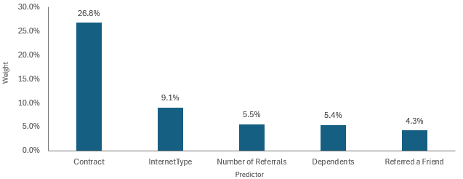
Fig 6. Feature Importance for XG Boosting Model
ROC Curve
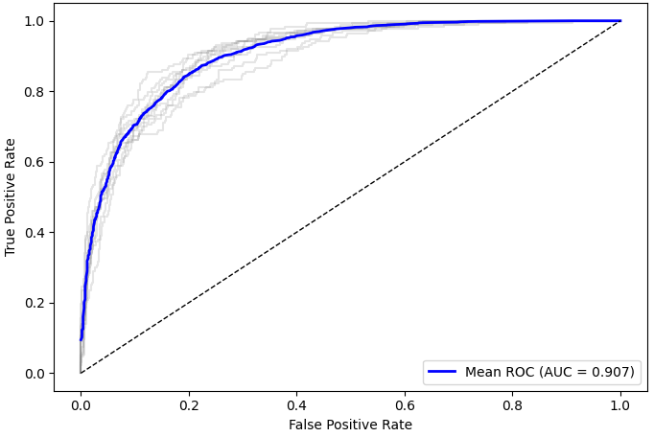
Fig 7. ROC Curve for XG Boosting Model

5.4 Random Forest
Random Forest is the model that is most used for churn prediction and classification problems. The overall result is decent, with 62% of the True Positive identification and outstanding 93% of True False Rate, however the False Negative Rate was still above 10%, which led to an overall F1 Score of 68.4% and a Recall Score of XXXX.
The model was also tuned in a few parameters such as maximum depth, maximum features, minimum samples per leaf, minimum samples per split and the number of estimators. The table below shows the optimal parameters.
max_depth | 10
max_features | sqrt
min_samples_leaf | 2
min_samples_split | 10
n_estimators | 200
Table 2: Optimal Parameters for Random Forest

Feature Importance
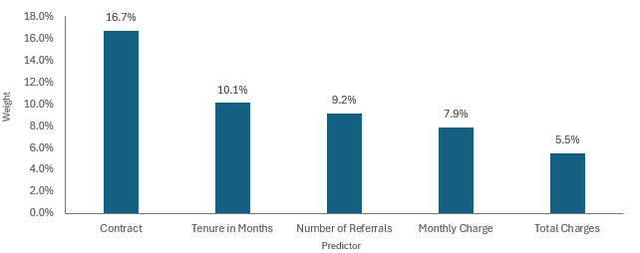
Fig 8. Feature Importance for Random Forest Model
ROC Curve
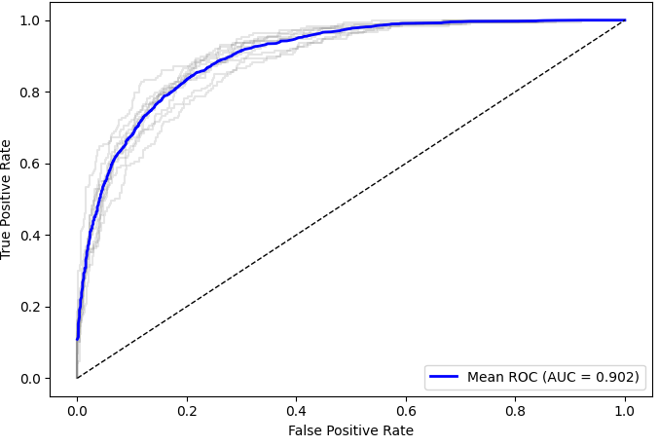
Fig 9. ROC Curve for Random Forest Model

5.5 Light Gradient Boosting Model (LightGBM)
The last model that was tested was LightGBM, which shares lots of similarities with XG Boosting, but presents a few improved qualities such as speed on dealing with large datasets and has a different tree growth strategy (leaf-wise instead of level-wise for XGBoosting).
The result for LightGBM follows, as expected, the same pattern as XGBoost with 66% of TPR and 92% FPR. Also, the average F1 Score was 70.1% and the Recall Score across folds was 66.5%.
Lastly, this was the model that performed best within the ROC Curve, with an average AUC of 90.9% with the following optimal parameters:
learning_rate | 0.05
max_depth | 3
Table 3: Optimal Parameters for LightGBM
Feature Importance
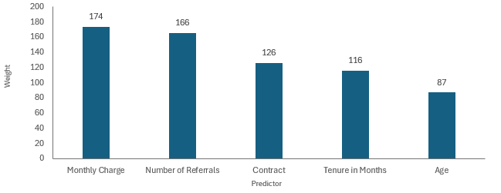
Fig 10. Feature Importance for LightGBM
ROC Curve
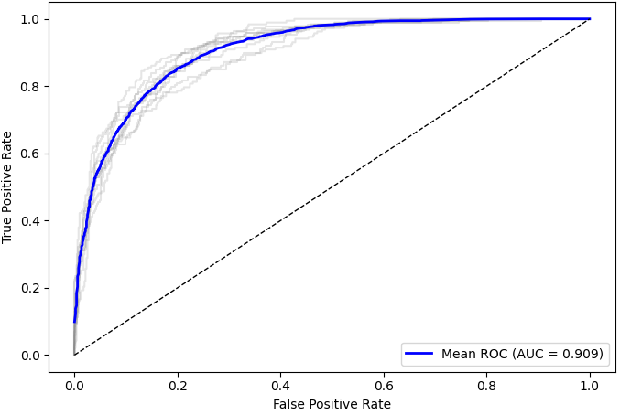
Fig 11. ROC Curve for LightGBM

- Results Summary

- Conclusion

- References

